Phụ lục II
QUY CÁCH VIẾT BÀI BÁO TIẾNG ANH
GỬI HỘI NGHỊ KHOA HỌC LẦN THỨ 17
CHÀO MỪNG KỶ NIỆM 55 NĂM NGÀY TRUYỀN THỐNG
HỌC VIỆN KỸ THUẬT QUÂN SỰ (28/10/1966 - 28/10/2021)
(Kèm theo Thông báo số: 1329/TB-BTC ngày 13/4/2021
của Học viện Kỹ thuật Quân sự)

THE TITLE OF THE PAPER ACCURATELY REFLECTS THE RESEARCH AND THE PRESENTED CONTENT
Nguyen Van A¹*, Vu Thi B²
¹Affiliation X (University of…., Hanoi, Vietnam); ²Affiliation Y
Abstract
The abstract should clearly state the research objectives, research methods, scientific bases, achieved results and the significance of the research. Summary content should not be too long, usually no more than 200 words. In summary, avoid abbreviations, avoid using quotes, not links. In case the abbreviations are common keywords, they are allowed to use, for example, CDMA, CNC...
Keywords: Component; formatting; style; styling; insert (3-5 key words)
1. Introduction
The introduction should clarify the state of the art of research related to the study presented in this paper. The advantages and limitations of existing studies need to be figured out. In particular, it is necessary to specify the difference of this study.
Note, the content of this section must follow the paper title or follow the keywords.
When analyzing the state of the art, the cited references must truthfully and accurately reflect the relevant content outlined in the paper. Avoid citing bibliographic references like listing.
The end of the introduction should highlight the necessary, then introduce the next structure of the paper.
All standard paper components have been specified for three reasons: (1) ease of use when formatting individual papers, (2) automatic compliance to electronic requirements that facilitate the concurrent or later production of electronic products, and (3) conformity of style throughout a conference proceedings.
Margins, column widths, line spacing, and type styles are built-in. PLEASE DO NOT RE-ADJUST THESE MARGINS. Some components, such as multi-leveled equations, graphics, and tables are not prescribed, although the various table text styles are provided. The formatter will need to create these components, incorporating the applicable criteria that follow.
2. Methodology
In this section, the author can present the main research method or scientific bases for the research.
For published scientific institutions, the author should add a source of citations for readers to contact for detailed information.
For scientific bases created by the author itself, it is necessary to emphasize and describe in detail so that readers can understand the problem.
Wherever Times is specified, Times Roman or Times New Roman may be used. If neither is available on your word processor, please use the font closest in appearance to Times. Avoid using bit-mapped fonts if possible. True-Type 1 or Open Type fonts are preferred. Please embed symbol fonts, as well, for math, etc.
3. System information and details
3.1. System information
System information gives readers an overview of the author's research.
First, confirm that you have the correct template for your paper size. This template has been tailored for output on the US-letter paper size. If you are using A4-sized paper, please close this template and download the file for A4 paper format called “CPS_A4_format”.
3.2. Details
Detailed information helps readers drill down on each aspect of the author's research. From there, learn more about the general mechanism of the system.
The template is used to format your paper and style the text. All margins, column widths, line spaces, and text fonts are prescribed; please do not alter them. You may note peculiarities. For example, the head margin in this template measures proportionately more than is customary. This measurement and others are deliberate, using specifications that anticipate your paper as one part of the entire proceedings, and not as an independent document. Please do not revise any of the current designations.
4. Using mathematical formulas
Before drafting a mathematical formula, firstly making sure that you are using the right tool for the Journal's requirements (eg. Mathtype, Equation ...).
The easiest way to draft the paper is to copy your formula into the sample formula in this template.
4.1. Using symbols
Define abbreviations and acronyms the first time they are used in the text, even after they have been defined in the abstract. Abbreviations such as ASME, SI, MKS, CGS, sc, dc, and rms do not have to be defined. Do not use abbreviations in the title or heads unless they are unavoidable.
4.2. Measuring units
- Use either SI (MKS) or CGS as primary units. (SI units are encouraged.) English units may be used as secondary units (in parentheses). An exception would be the use of English units as identifiers in trade, such as “3.5-inch disk drive”.
- Avoid combining SI and CGS units, such as current in amperes and magnetic field in oersteds. This often leads to confusion because equations do not balance dimensionally. If you must use mixed units, clearly state the units for each quantity that you use in an equation.
- Do not mix complete spellings and abbreviations of units: “Wb/m²” or “webers per square meter”, not “webers/m2”. Spell out units when they appear in text: “... a few henries”, not “. . . a few H”.
- Use a zero before decimal points: “0.25”, not “.25”.

4.3. Using equations
The equations are an exception to the prescribed specifications of this template. You will need to determine whether or not your equation should be typed using either the Times New Roman or the Symbol font (please no other font). To create multileveled equations, it may be necessary to treat the equation as a graphic and insert it into the text after your paper is styled.
Number equations consecutively. Equation numbers, within parentheses, are to position flush right, as in (1), using a right tab stop. To make your equations more compact, you may use the solidus (/), the exp function, or appropriate exponents. Italicize Roman symbols for quantities and variables, but not Greek symbols. Use a long dash rather than a hyphen for a minus sign. Punctuate equations with commas or periods when they are part of a sentence, as in
(1)
Note that the equation is centered using a center tab stop. Be sure that the symbols in your equation have been defined before or immediately following the equation. Use “(1)”, not “Eq. (1)” or “equation (1)”, except at the beginning of a sentence: “Equation (1) is . . .”
4.4. Common mistakes
- The word “data” is plural, not singular.
- The subscript for the permeability of vacuum μ₀, and other common scientific constants, is zero with subscript formatting, not a lowercase letter “o”.
- In American English, commas, semi-/colons, periods, question and exclamation marks are located within quotation marks only when a complete thought or name is cited, such as a title or full quotation. When quotation marks are used, instead of a bold or italic typeface, to highlight a word or phrase, punctuation should appear outside of the quotation marks. A parenthetical phrase or statement at the end of a sentence is punctuated outside of the closing parenthesis (like this). (A parenthetical sentence is punctuated within the parentheses.)
- A graph within a graph is an “inset”, not an “insert”. The word alternatively is preferred to the word “alternately” (unless you really mean something that alternates).
- Do not use the word “essentially” to mean “approximately” or “effectively”.
- In your paper title, if the words “that uses” can accurately replace the word “using”, capitalize the “u”; if not, keep using lower-cased.
- Be aware of the different meanings of the homophones “affect” and “effect”, “complement” and “compliment”, “discreet” and “discrete”, “principal” and “principle”.
- Do not confuse “imply” and “infer”.
- The prefix “non” is not a word; it should be joined to the word it modifies, usually without a hyphen.
- There is no period after the “et” in the Latin abbreviation “et al.”.
- The abbreviation “i.e.” means “that is”, and the abbreviation “e.g.” means “for example”.
An excellent style manual for science writers is [7].
5. Results
Tables and figures are tools for visually displaying data or research results.
5.1. Tables
Sample tables are created as shown in the Table 1.
Table 1. Table Type Styles
Table Head | Table Column Head
Table Head | Table column subhead | Subhead | Subhead
copy | More table copyª

Use footnotes sparingly (or not at all) and place them at the bottom of the column on the page on which they are referenced. Use Times 10-point type, single-spaced. To help your readers, avoid using footnotes altogether and include necessary peripheral observations in the text (within parentheses, if you prefer, as in this sentence).
5.2. Figures
The figure should be clear and easily distinguishable. Figure 1 is an example illustrating the experimental setup. Figure 2 shows an example of a test result with multiple drawings. The figures should be marked a, b, c, d. Also have to describe the drawings.
All drawings must be analyzed in writing. Avoid providing drawings but do not use in the article.
Images created from many different shapes should be shown in a frame (New Drawing Canvas in Shapes).
If other people's drawings are used, the citations should be clearly stated in respect of its creators.
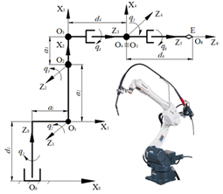
Fig. 1. Example of a ONE-COLUMN figure caption.

Place figures and tables at the top and bottom of columns. Avoid placing them in the middle of columns. Large figures and tables may span across both columns. Figure captions should be below the figures; table heads should appear above the tables. Insert figures and tables after they are cited in the text. Use the abbreviation “Fig. 1”, even at the beginning of a sentence.

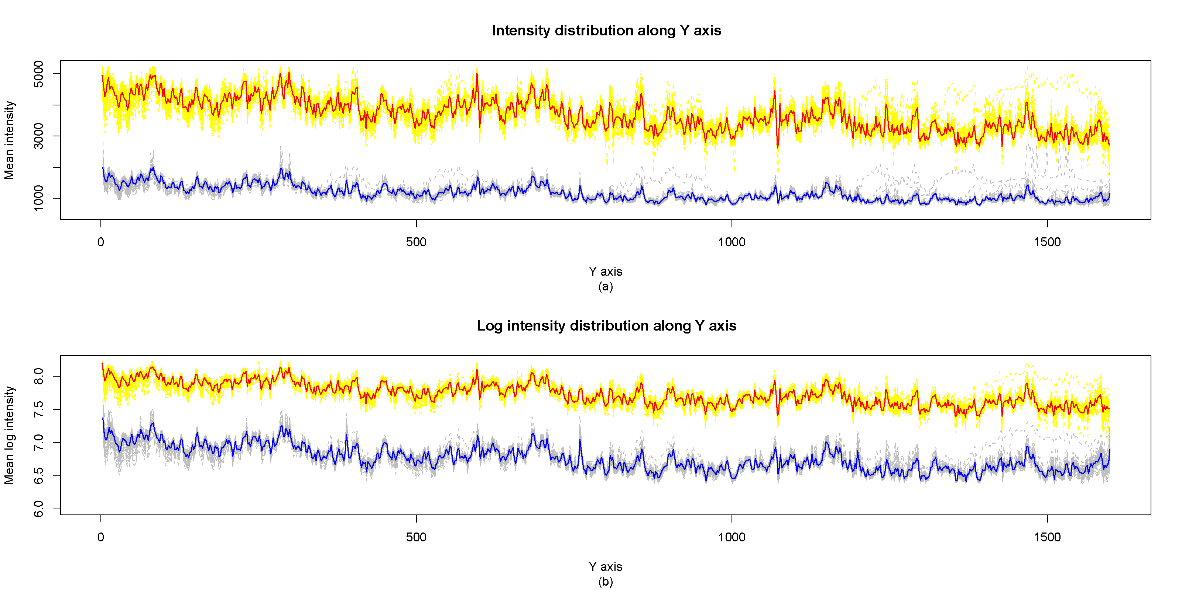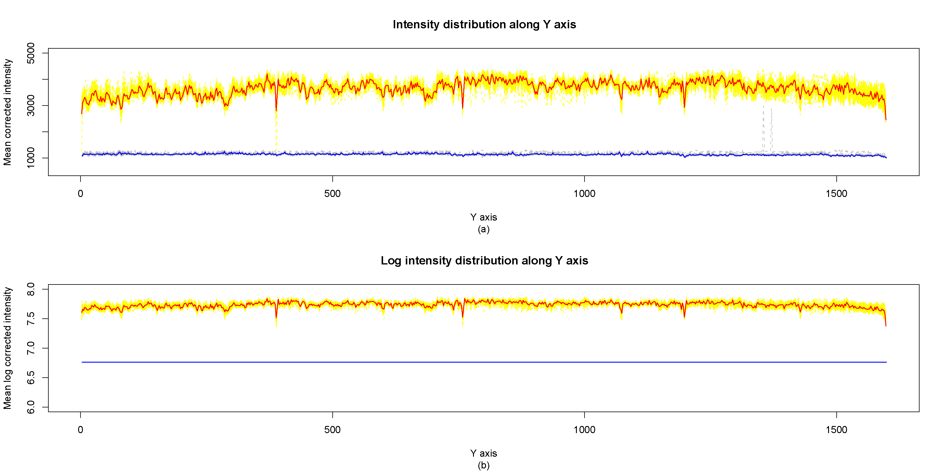
Fig. 2. Example of a TWO-COLUMN figure caption:
(a) this is the format for referencing parts of a figure.
Use 10 point Times New Roman for Figure labels. Use words rather than symbols or abbreviations when writing Figure axis labels to avoid confusing the reader. As an example, write the quantity “Magnetization”, or “Magnetization, M”, not just “M”. If including units in the label, present them within parentheses. Do not label axes only with units. In the example, write “Magnetization (A/m)” or “Magnetization {A[m(1)]}”, not just “A/m”. Do not label axes with a ratio of quantities and units. For example, write “Temperature (K)”, not “Temperature/K”.
6. Conclusion
The conclusion needs to be brief. It shows the achieved contents of the article. It should emphasize the difference of this study compared to other studies.
The significance of the research results and the next development direction should be clarified.
Acknowledgement
In case that the paper research concerns funding sources, the author should include this item.
The preferred spelling of the word “acknowledgment” in America is without an “e” after the “g”. Avoid the stilted expression, “One of us (R.B.G.) thanks . . .”. Instead, try “R.B.G. thanks”. Put applicable sponsor acknowledgments here; DO NOT place them on the first page of your paper or as a footnote.
References
The reference needs to make it clear Who is the author? What is the title? Place of publication? Publication time? More precisely, specify relevant pages.
For the reference links, it is necessary to record the update time and put them in parentheses (put after).
For the reference books: the title is written in vertical and enclosed in quotation marks "Brochure...". Publisher name needs italicization. In particular, the page of the relevant book or chapter shall be specified with reference to the cited content.
For the reference papers: The paper name is written in italics and enclosed in quotation marks "Paper...". The name of the conference or seminar is to be written directly. The number of paper pages should be clearly stated regarding the cited content.
For the reference report: the report name is written in vertical and enclosed in quotation marks "Report...". The report should be italicized. The report year is listed at the end.
For the reference paper is not known where the publication: paper name is written in italics and enclosed in quotation marks "Article ...". Provide the link at the back.
References in books
- G. Eason, B. Noble, and I. N. Sneddon, “On certain integrals of Lipschitz-Hankel type involving products of Bessel functions,” Phil. Trans. Roy. Soc. London, vol. A247, pp. 529–551, April 1955. (references)
- J. Clerk Maxwell, A Treatise on Electricity and Magnetism, 3rd ed., vol. 2. Oxford: Clarendon, 1892, pp. 68–73.
- I. S. Jacobs and C. P. Bean, “Fine papers, thin films and exchange anisotropy,” in Magnetism, vol. III, G. T. Rado and H. Suhl, Eds. New York: Academic, 1963, pp. 271–350.
- K. Elissa, “Title of paper if known,” unpublished.
- R. Nicole, “Title of paper with only first word capitalized,” J. Name Stand. Abbrev., in press.
- Y. Yorozu, M. Hirano, K. Oka, and Y. Tagawa, “Electron spectroscopy studies on magneto-optical media and plastic substrate interface,” ASME Transl. J. Magn. Japan, vol. 2, pp. 740–741, August 1987 [Digests 9th Annual Conf. Magnetics Japan, p. 301, 1982].
- M. Young, The Technical Writer’s Handbook. Mill Valley, CA: University Science, 1989.
- Electronic Publication: Digital Object Identifiers (DOIs):
References in Journals:
- D. Kornack and P. Rakic, “Cell Proliferation without Neurogenesis in Adult Primate Neocortex,” Science, vol. 294, Dec. 2001, pp. 2127-2130, doi:10.1126/science.1065467.
References in conference proceedings:
- H. Goto, Y. Hasegawa, and M. Tanaka, “Efficient Scheduling Focusing on the Duality of MPL Representatives,” Proc. ASME Symp. Computational Intelligence in Scheduling (SCIS 07), ASME Press, Dec. 2007, pp. 57-64, doi:10.1109/SCIS.2007.357670.
TIÊU ĐỀ CỦA BÀI BÁO NÊN PHẢN ÁNH NỘI DUNG CHÍNH CỦA BÀI BÁO HOẶC CÁC KẾT QUẢ CHÍNH CỦA NGHIÊN CỨU
GS.TS. Nguyễn Văn A - Viện Cơ học/Viện Hàn lâm KH&CN Việt Nam
ThS. Vũ Thị B - Khoa Cơ khí/Học viện KTQS
Tóm tắt: Phần này được viết bằng tiếng Việt; cần nêu sơ bộ mục tiêu nghiên cứu, phương pháp nghiên cứu chính và kết quả chính sẽ được phản ánh trong bài; có thể chỉ ra ý nghĩa của nghiên cứu hoặc hướng phát triển tiếp theo; được soạn bằng mã Unicode, font chữ Times New Roman, dài không quá 200 từ, cỡ chữ 11. Tài liệu tham khảo không nên trích dẫn trong phần này. Không nên sử dụng các ký tự, ký hiệu đặc biệt, hoặc công thức toán trong tiêu đề bài báo hoặc tóm tắt.
Keywords: Thành phần; định dạng; phong cách; kiểu dáng; chèn (3-5 từ khóa)
Received: …/…/2020; Revised: …/…/2020; Accepted for publication: …/…/2020
q

* Email: corresponding author@lqdtu.edu.vn (corresponding author); Contact number:.................

